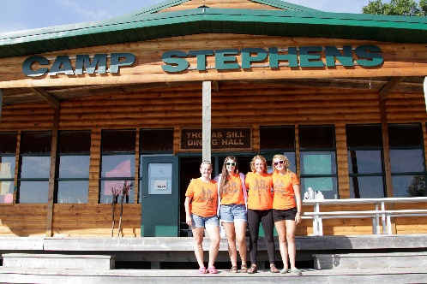
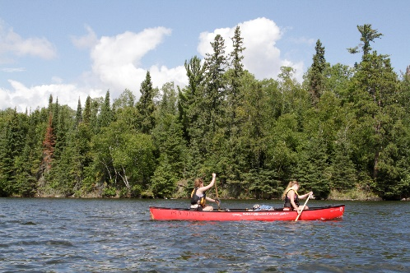
–––
JOIN OUR TEAM!

Assistant Kitchen Coordinator, Full Time
New hire-$98.33 per day & Returning staff-$103.33 per day
Camp Stephens, Lake of the Woods, Kenora, Ontario (Live on Site)
May 17–September 1, 2023 (subject to change)

Do you love working with children? Want to help provide a high-quality camp experience for every child? Excited about spending your Spring and Summer on an island in beautiful Lake of the Woods? Camp Stephens provides a unique opportunity for everyone. As the Assistant Kitchen Coordinator you will facilitate the smooth and proper operation of the food management system delivering healthy meals to campers and staff.
Are you the right fit?
- Provide leadership, training and role modeling to all employees and volunteers
- Ensure food safety standards and policies are implemented and practiced by all staff
- Plan appropriate menus and maintain food supply inventory
- Ensure high quality, ample meals are prepared in a timely manner
- Oversee cleanliness and upkeep of the kitchen and dining hall
- Perform budget management, report writing and various administrative duties
What else do you need?
- Standard First Aid
- Food Handler’s Certificate
- Prior experience in commercial/institutional food preparation
- Fully immunized against COVID-19 or valid exemption
Assets:
- National Lifeguard (NL)
- Bronze Cross
Why work at the Y?
- Great people and work environment with an amazing view
- Complimentary Y individual membership
- Many opportunities for growth and advancement
- Super rewarding job, nourishing kids at camp
- We are awesome!

Submit your cover letter and resume by January 31, 2023 to: mat.klachefsky@ymanitoba.ca

