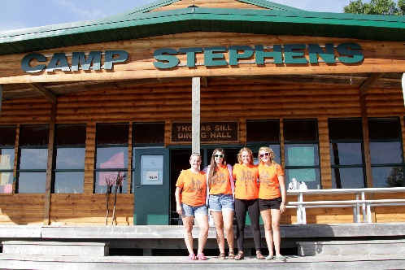
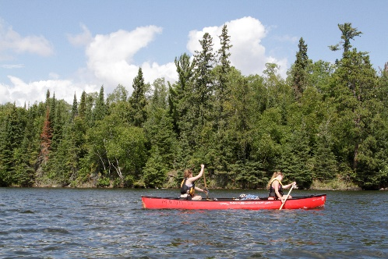
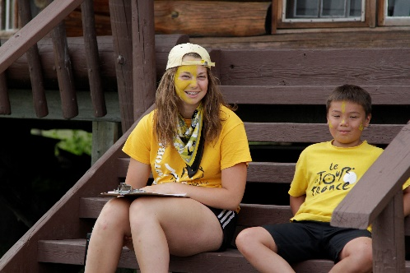
–––
JOIN OUR TEAM!

Assistant Camp Director, Full Time-$150.05 per day
Camp Stephens, Lake of the Woods, Kenora, Ontario (Live on Site)
June 6-September 2, 2022 (subject to change)

Do you love working with children? Want to help provide a high-quality camp experience for every child? Excited about spending your Spring and Summer on an island in beautiful Lake of the Woods? Camp Stephens provides a unique opportunity for everyone. As the Assistant Camp Director, you will oversee the administration and delivery of the Camp Stephens program.

Are you the right fit?
- Provide leadership, training and role modeling to all employees and volunteers
- Assist in the hiring process and lead employees in compliance with policies and procedures
- Able to implement and deliver all in-camp programming
- Perform budget management, report writing and various administrative duties
- Strong communication and interpersonal skills

What else do you need?
- Prior experience working at a camp
- Standard First Aid
- Bronze Cross
- Fully immunized against COVID-19 or valid exemption

Assets:
- Pleasure Craft License
- OCA Camp Marine Module Training Course
- National Lifeguard (NL)
- Wilderness Advanced First Aid
- High Ropes Level 2, CanSail 2 or Equivalent
- Other outdoor activity certifications

Why work at the Y?
- Great people and work environment with an amazing view
- Complimentary Y individual membership
- Many opportunities for growth and advancement
- Super fun job, teaching life skills to kids
- We are awesome!

Submit your cover letter and resume by December 3, 2021 to: mat.klachefsky@ymanitoba.ca

The YMCA-YWCA of Winnipeg is committed to providing a safe environment for children and vulnerable individuals. All applicants will be thoroughly screened through a review process including Police Record Checks with Vulnerable Sector Search and Child Abuse Registry Checks. We thank you for your interest; however, only candidates selected for an interview will be contacted.
If you are hired, prior to your start date and as a condition of your employment, you will be required to provide proof that you are fully immunized against COVID-19 or have a valid exemption.

