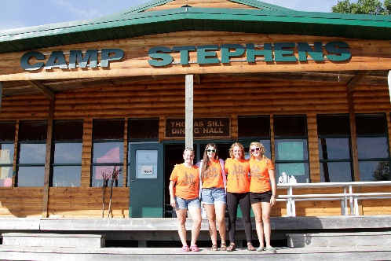
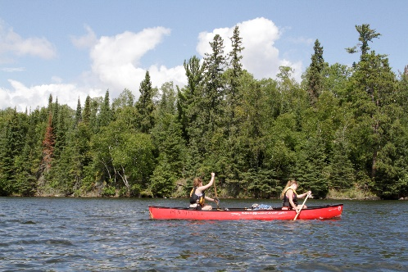
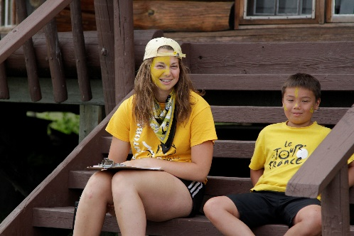
–––
JOIN OUR TEAM!

Operations Staff, Full Time
New hire-$350.00 per week & Returning staff-$375.00 per week (plus room & board)
Camp Stephens, Lake of the Woods, Kenora, Ontario (Live on Site)
May 15-June 23, 2023 (Spring)
June 25–September 1, 2023 (Summer-subject to change)

Do you love working with children? Want to help provide a high-quality camp experience for every child? Excited about spending your Spring and Summer on an island in beautiful Lake of the Woods? Camp Stephens provides a unique opportunity for everyone. Operation staff members ensure that the facility is a safe and clean environment and that all site facilities, installations and equipment are in good working order.

Are you the right fit?
- Perform regular maintenance as required
- Assist with ensuring camping industry and Y safety standards and policies are implemented and practiced by all staff and campers
- Perform errand running duties as required
- Provide assistance in emergency situations
- Ensure safe operation of boats and safety of passengers in boats
- Providing additional support to the larger team as needed

What else do you need?
- Standard First Aid & CPR C
- Bronze Cross
- Pleasure Craft Operator Card (PCOC)
- Minimum Class 5F License or equivalent and Driver’s Abstract
- Globally Harmonized System (will train)
- Fully immunized against COVID-19 or valid exemption
Assets:
- National Lifeguard (NL)
- Class 4 Driver’s License and drivers abstract
- Marine Emergency Duties (MED A3)
- Small Vessel Operator Training (SVOP)

Why work at the Y?
- Great people and work environment with an amazing view
- Complimentary Y individual membership
- Many opportunities for growth and advancement
- Super rewarding job, helping kids have a remarkable camp experience
- We are awesome!

Submit your cover letter and resume by January 31, 2023 to: mat.klachefsky@ymanitoba.ca

