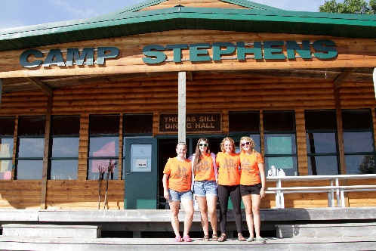
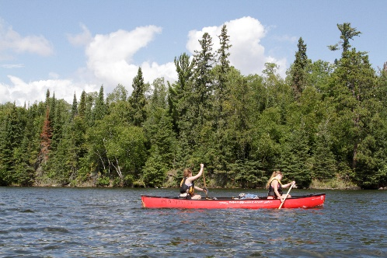
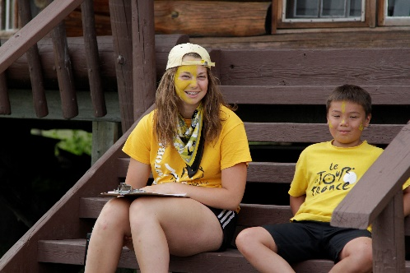
–––
JOIN OUR TEAM!

Six Week Tripper, Full Time (Four Positions Available)
Camp Stephens, Lake of the Woods, Kenora, Ontario (Live on Site)
June 26–August 27, 2022 (subject to change)

Do you love working with children? Want to help provide a high-quality camp experience for every child? Excited about spending your Spring and Summer on an island in beautiful Lake of the Woods? Camp Stephens provides a unique opportunity for everyone. As a part of the Camp Stephens Wilderness team, the Tripper will provide expertise, experience and skills specific to wilderness canoe tripping and are responsible for planning and leading the 6-week canoe trip.

Are you the right fit?
- General camper care including managing behaviours
- Coordinate canoe trip including packing food and equipment
- Ensure safe wilderness tripping for all campers
- Complete administrative duties

What else do you need?
- Minimum Class 5F License or equivalent with driver abstract
- Wilderness Advanced First Aid/Wilderness First Responder with CPR Level C
- Global Harmonized System certification (GHS) - employer will train
- Bronze Cross
- 2+ years of remote canoe trip leading experience
- Fully immunized against COVID-19 or valid exemption

Assets:
- Paddle Canada Canoe Tripping or Moving Water certification
- Paddle Canada Instructor
- National Lifeguard (NL)
- Swiftwater Rescue Technician (SRT)

Why work at the Y?
- Great people and work environment with an amazing view
- Complimentary Y individual membership
- Many opportunities for growth and advancement
- Super rewarding job, helping kids connect with nature
- We are awesome!

Submit your cover letter and resume by December 3, 2021 to: mat.klachefsky@ymanitoba.ca

The YMCA-YWCA of Winnipeg is committed to providing a safe environment for children and vulnerable individuals. All applicants will be thoroughly screened through a review process including Police Record Checks with Vulnerable Sector Search and Child Abuse Registry Checks. We thank you for your interest; however, only candidates selected for an interview will be contacted.
If you are hired, prior to your start date and as a condition of your employment, you will be required to provide proof that you are fully immunized against COVID-19 or have a valid exemption.

