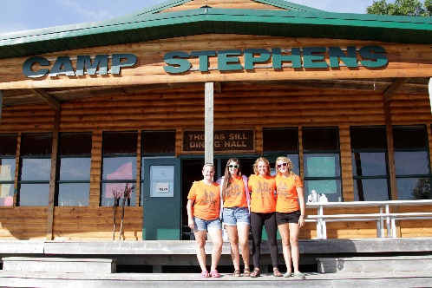
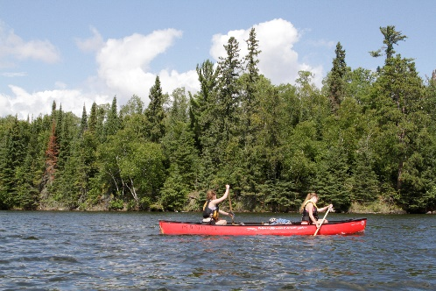
–––
JOIN OUR TEAM!

Leadership Development Program Coordinator, Full Time
Camp Stephens, Lake of the Woods, Kenora, Ontario (Live on Site)
June 27–August 28, 2021

Please note that the date for resuming Camp Stephens operations remains unknown at this time.
Public health restrictions and/or operational requirements may prevent our re-opening in 2021.

Do you love working with children? Want to help provide a high quality camp experience for every child? Excited about spending your Spring and Summer on an island in beautiful Lake of the Woods? Camp Stephens provides a unique opportunity for everyone. As a part of the Camp Stephens Leadership Staff team, the LDP Coordinator will provide expertise, experience, and skills to a youth team of LDP participants at our very busy camp.

Are you the right fit?
- Provide supervision, feedback and guidance to Leadership Development Program participants
- Assist in staff training
- Ensure safe programming is delivered following policies and procedures
- Provide a written end of season report of the program and the participants
- Providing additional support to the larger team as needed

What else do you need?
- Global Harmonized System certification (GHS) -employer will train
- Standard First Aid and Bronze Cross
- Prior camp experience or experience working with children and youth

Assets:
- National Lifeguard (NL)
- Wilderness Advanced First Aid (WAFA)

Why work at the Y?
- Great people and work environment with an amazing view
- Complimentary Y individual membership
- Many opportunities for growth and advancement
- Super rewarding job, helping kids connect with nature
- We are awesome!

Submit your cover letter and resume by March 19, 2021 to: mat.klachefsky@ymanitoba.ca
The YMCA-YWCA of Winnipeg is committed to providing a safe environment for children and vulnerable individuals. All applicants will be thoroughly screened through a review process including Police Record Checks with Vulnerable Sector Search and Child Abuse Registry Checks. We thank you for your interest; however, only candidates selected for an interview will be contacted.

