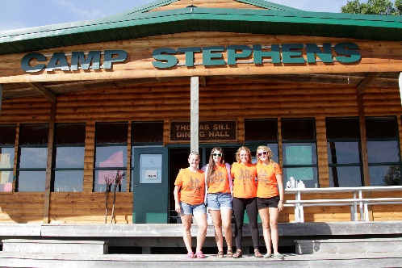
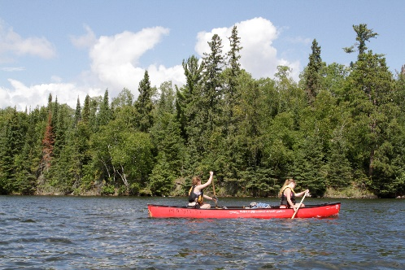
–––
JOIN OUR TEAM!

Section Coordinator, Full Time (3 Positions)
Camp Stephens, Lake of the Woods, Kenora, Ontario (Live on Site)
June 27–August 28, 2021

Please note that the date for resuming Camp Stephens operations remains unknown at this time.
Public health restrictions and/or operational requirements may prevent our re-opening in 2021.

Do you love working with children? Want to help provide a high quality camp experience for every child? Excited about spending your Spring and Summer on an island in beautiful Lake of the Woods? Camp Stephens provides a unique opportunity for everyone. As a part of the Camp Stephens Leadership Staff team, the Section Coordinator will provide leadership, guidance and training to a team of likeminded counsellors at our amazing facility on Lake of the Woods.

Are you the right fit?
- Provide behavior management and general camper care
- Provide leadership and role modeling to direct reports and campers
- Ensure safe programming is delivered following policies and procedures
- Training, supervising and evaluating camp counsellors and assistant counsellors
- Complete administrative duties
- Assist in staff training

What else do you need?
- Global Harmonized System certification (GHS) -employer will train
- Standard First Aid
- Bronze Cross
- Prior camp experience or experience working with children and youth

Assets:
- National Lifeguard (NL)
- Wilderness Advanced First Aid (WAFA)

Why work at the Y?
- Great people and work environment with an amazing view
- Complimentary Y individual membership
- Many opportunities for growth and advancement
- Super rewarding job, helping kids connect with nature
- We are awesome!

Submit your cover letter and resume by March 19, 2021 to: mat.klachefsky@ymanitoba.ca
The YMCA-YWCA of Winnipeg is committed to providing a safe environment for children and vulnerable individuals. All applicants will be thoroughly screened through a review process including Police Record Checks with Vulnerable Sector Search and Child Abuse Registry Checks. We thank you for your interest; however, only candidates selected for an interview will be contacted.

