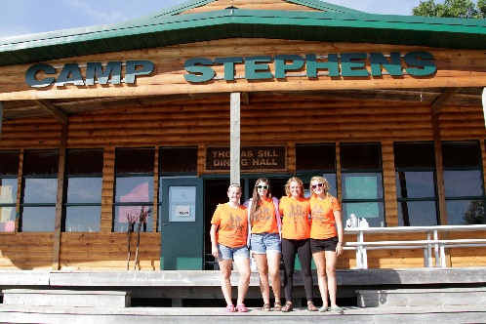
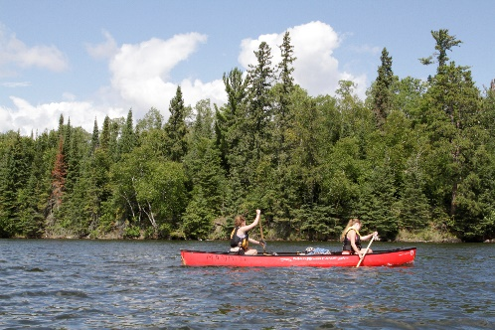
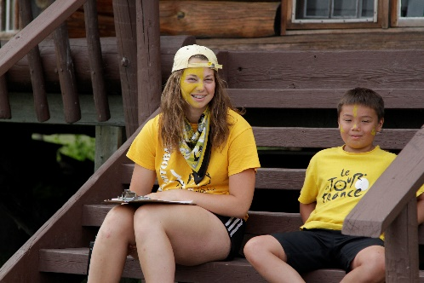
–––
JOIN OUR TEAM!

Preschool Child Care Provider, Full Time
New hire-$350.00 per week & Returning staff-$375.00 per week (plus room & board)
Camp Stephens, Lake of the Woods, Kenora, Ontario (Live on Site)
May 15-June 23, 2023 (Spring)
June 25–September 1, 2023 (Summer-subject to change)

Do you love working with children? Want to help provide a high-quality camp experience for every child? Excited about spending your Spring and Summer on an island in beautiful Lake of the Woods? Camp Stephens provides a unique opportunity for everyone. As the Preschool Child Care Provider, you will work with the Camp Director’s family to provide care for their child(ren) from the hours of 9:00 am – 5:30 pm, Monday-Friday. Other camp duties will be assigned outside of these hours.

Are you the right fit?
- Enjoy working with preschool children
- Able to prepare creative programming for preschool children
- Honest, trustworthy and respectful in your approach with children
- Enjoy swimming
- Able to work as part of a team and are self-motivated
- Able to provide support to other team members as needed

What else do you need?
- Standard First Aid
- Bronze Cross
- Globally Harmonized System (will train)
- Experience caring for toddlers and preschool children
- Strong organizational and time management skills
- Strong communication and interpersonal skills
- Exceptional customer service skills

Why work at the Y?
- Great people and work environment with an amazing view
- Complimentary Y individual membership
- Room, board and meals provided
- Super rewarding job
- We are awesome!

Submit your cover letter and resume by January 31, 2023 to: mat.klachefsky@ymanitoba.ca

