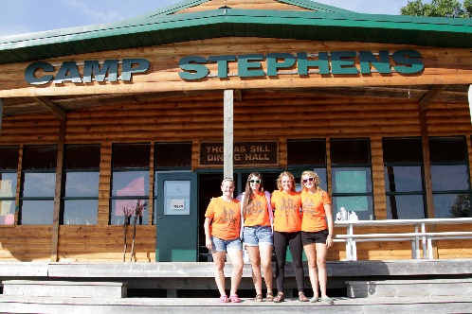
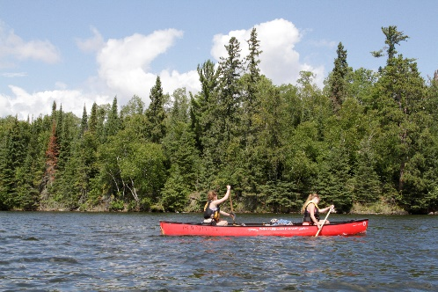
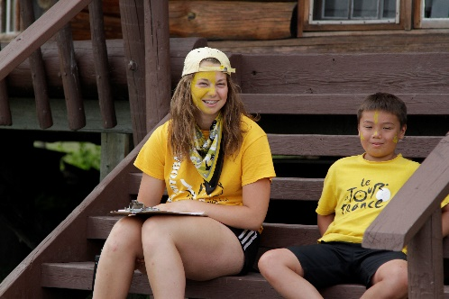
–––
JOIN OUR TEAM!

Kitchen Staff, Full Time
New hire-$350.00 per week & Returning staff-$375.00 per week (plus room & board)
Camp Stephens, Lake of the Woods, Kenora, Ontario (Live on Site)
June 25–September 1, 2023 (subject to change)

Do you love working with children? Want to help provide a high-quality camp experience for every child? Excited about spending your Spring and Summer on an island in beautiful Lake of the Woods? Camp Stephens provides a unique opportunity for everyone. As a Kitchen Staff you will assist with facilitating the smooth and proper operation of the food management system delivering healthy meals to campers and staff.
Are you the right fit?
- Able to assist in food preparation and cooking/baking
- Able to perform cleaning duties (dishwashing, cleaning and sanitizing kitchen tools, appliances, surfaces)
- Able to ensure Food Safe standards up being met while practicing safe working procedures
- Able to ensure the work area is free of hazards and safe to operate on a daily basis
- Able to assist in regular inspection of the kitchen equipment
- Able to ensure that meals are served on time, are of high quality and amounts are sufficient for the group

What else do you need?
- Must be at least 18 years of age or have a high school diploma
- Standard First Aid
- Globally Harmonized System (will train)
- Fully immunized against COVID-19 or valid exemption

Assets:
- Prior experience in commercial/institutional food preparation
- Food Handler’s Certificate
- Bronze Cross or National Lifeguard (NL)

Why work at the Y?
- Great people and work environment with an amazing view
- Complimentary Y individual membership
- Many opportunities for growth and advancement
- Super rewarding job, nourishing kids at camp
- We are awesome!

Submit your cover letter and resume by January 31, 2023 to: mat.klachefsky@ymanitoba.ca

