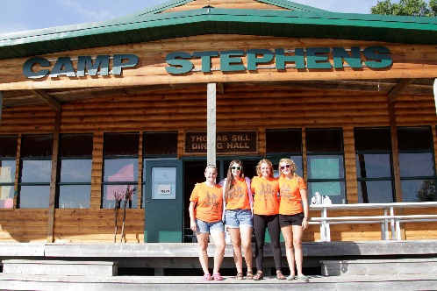
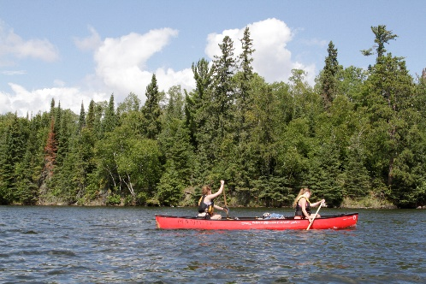
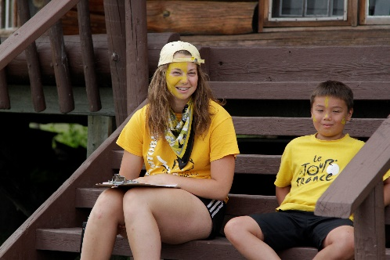
–––
JOIN OUR TEAM!

Leadership Development Program Coordinator, Full Time
(Two Positions Available)
New hire-$98.33 per day & Returning staff-$103.33 per day
Camp Stephens, Lake of the Woods, Kenora, Ontario (Live on Site)
June 25–August 26, 2023 (subject to change)

Do you love working with children? Want to help provide a high quality camp experience for every child? Excited about spending your Spring and Summer on an island in beautiful Lake of the Woods? Camp Stephens provides a unique opportunity for everyone. As a part of the Camp Stephens Leadership Staff team, the LDP Coordinator will provide expertise, experience, and skills to a youth team of LDP participants at our very busy camp.

Are you the right fit?
- Provide supervision, feedback and guidance to Leadership Development Program participants
- Assist in staff training
- Ensure safe programming is delivered following policies and procedures
- Provide a written end of season report of the program and the participants
- Providing additional support to the larger team as needed

What else do you need?
- Global Harmonized System certification (GHS) -employer will train
- Standard First Aid and Bronze Cross
- Prior camp experience or experience working with children and youth
- Fully immunized against COVID-19 or valid exemption
Assets:
- National Lifeguard (NL)
- Wilderness Advanced First Aid (WAFA)

Why work at the Y?
- Great people and work environment with an amazing view
- Complimentary Y individual membership
- Many opportunities for growth and advancement
- Super rewarding job, helping kids connect with nature
- We are awesome!

Submit your cover letter and resume by January 31, 2023 to: mat.klachefsky@ymanitoba.ca

