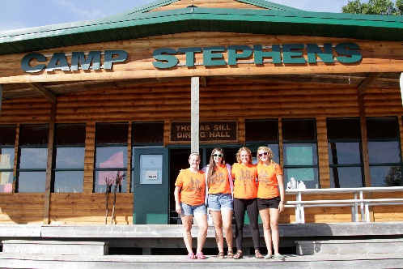
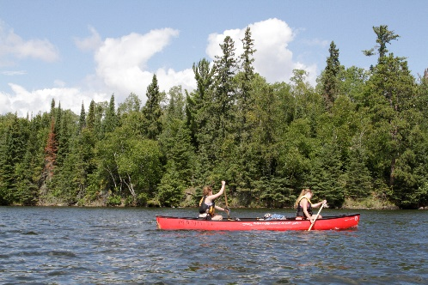
–––
JOIN OUR TEAM!

Wellness Coordinator, Full Time-$150.05 per day
Camp Stephens, Lake of the Woods, Kenora, Ontario (Live on Site)
June 6-September 2, 2022 (subject to change)

Do you love working with children? Want to help provide a high-quality camp experience for every child? Excited about spending your Spring and Summer on an island in beautiful Lake of the Woods? Camp Stephens provides a unique opportunity for everyone. As the Wellness Coordinator, you will provide expertise, experience and skills specific to the operation of the Camp Stephens Wellness Centre.

Are you the right fit?
- Provide leadership, training and role modeling to all employees and volunteers
- Provide wellness education and awareness
- Assess and treat campers and staff attending the Wellness Centre
- Report injuries and incidents to appropriate parties
- Maintain logs of all attendees of the Wellness Centre
- Maintain a log of medications dispensed
- Contact parents of campers with health related issues
- Manage health checks for all campers
- Manage budget and inventory of first aid supplies

What else do you need?
- Standard First Aid
- Bronze Cross (NL preferred)
- 80 hour Wilderness First Responder or
Nursing (2nd or 3rd year) or licensed Paramedic
- Fully Immunized against COVID-19 or valid exemption
Why work at the Y?
- Great people and work environment with an amazing view
- Complimentary Y individual membership
- Many opportunities for growth and advancement
- Super rewarding job, helping kids have a remarkable camp experience
- We are awesome!

Submit your cover letter and resume by December 3, 2021 to: mat.klachefsky@ymanitoba.ca

The YMCA-YWCA of Winnipeg is committed to providing a safe environment for children and vulnerable individuals. All applicants will be thoroughly screened through a review process including Police Record Checks with Vulnerable Sector Search and Child Abuse Registry Checks. We thank you for your interest; however, only candidates selected for an interview will be contacted.
If you are hired, prior to your start date and as a condition of your employment, you will be required to provide proof that you are fully immunized against COVID-19 or have a valid exemption.

